**Group: Asian Fusion**

Workshop Documentation

**Different topics:**

* Online shopping, finding the right size that fits the customer
* Online learning, making it fun and intractable
* Helping disabled people experience water slides

**Chosen Topic - Helping people with movement disability with experiencing water slides**

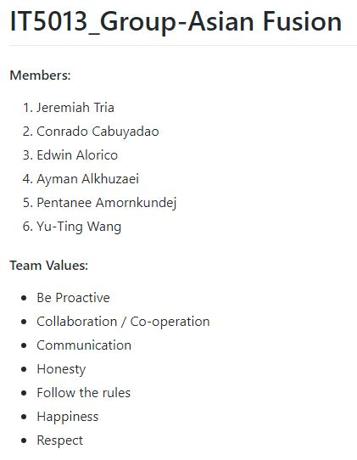***Task 1 is in the Asian Fusion README file on GitHub:***[*https://github.com/Jeep7654/IT5013_Group-Asian_Fusion*](https://github.com/Jeep7654/IT5013_Group-Asian_Fusion)

**Task 2**

**Key problems that we could think of are:**

1. It could be dangerous for those people with the disability to ride by themselves.
2. Their safety can be in danger.
3. What about different disabilities?
4. It can be a scary experience for a first time
5. What kind of equipment can we use?
6. Their overall experience may differentiate.
7. Since the topic is about physical disability some may not be able to be physically there.
8. 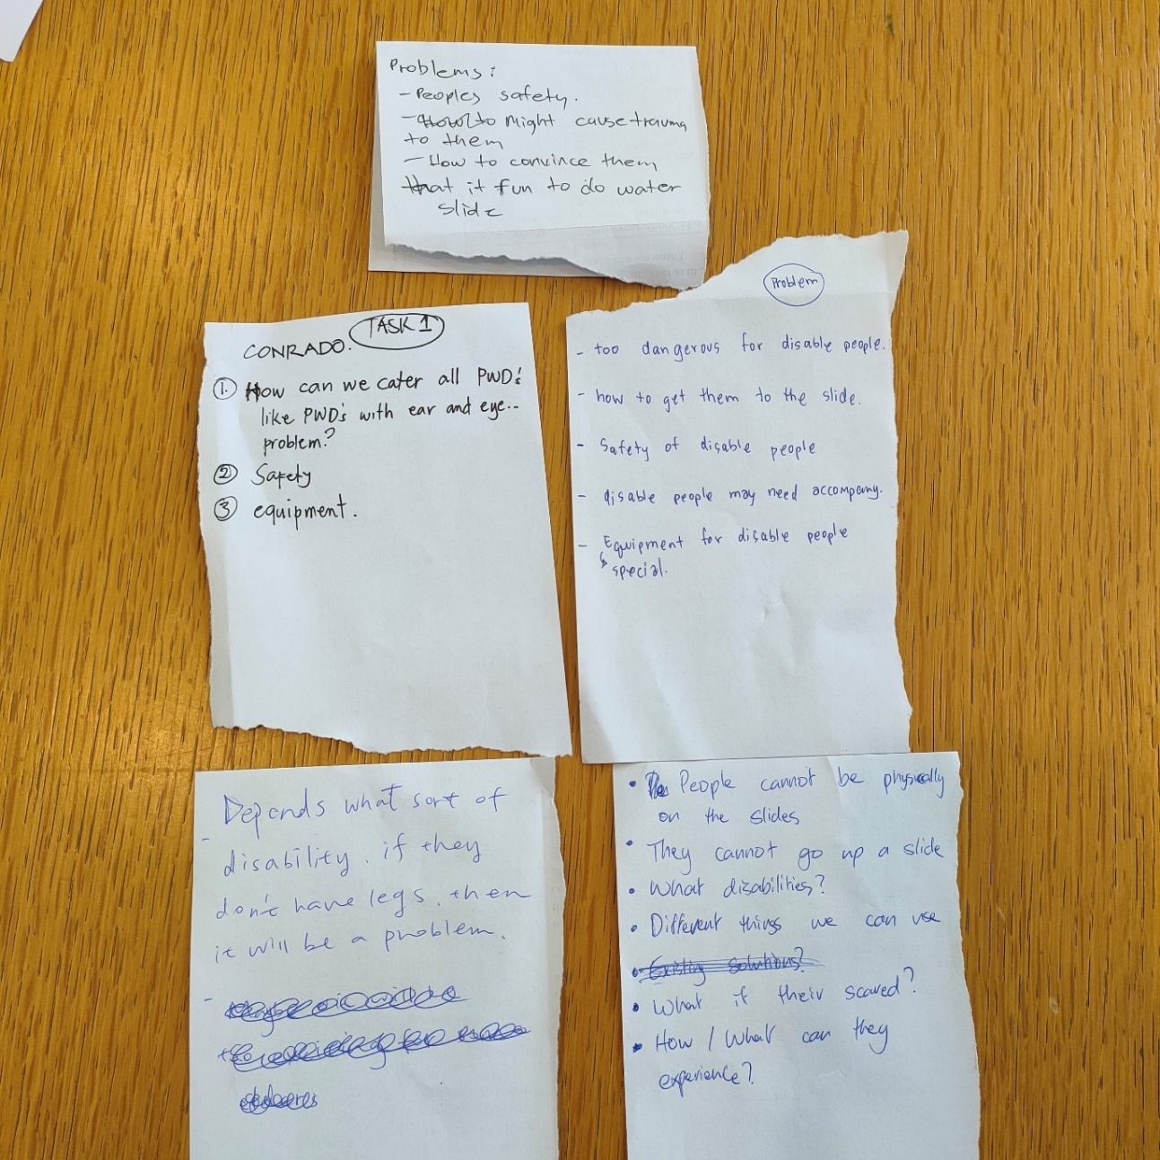How expensive can it get?

**Needs / Wants that we could think of:**

1. We would like to provide safety equipment.
2. We want to stick only with people with movement disabilities.
3. Provide a safety plan / orientation.
4. We want a special equipment.
5. Examination or information about the person’s disability to see if they are eligible to ride the slide.
6. We want it to be fun and it needs to be fun.
7. Want it to be as real as it can be.
8. 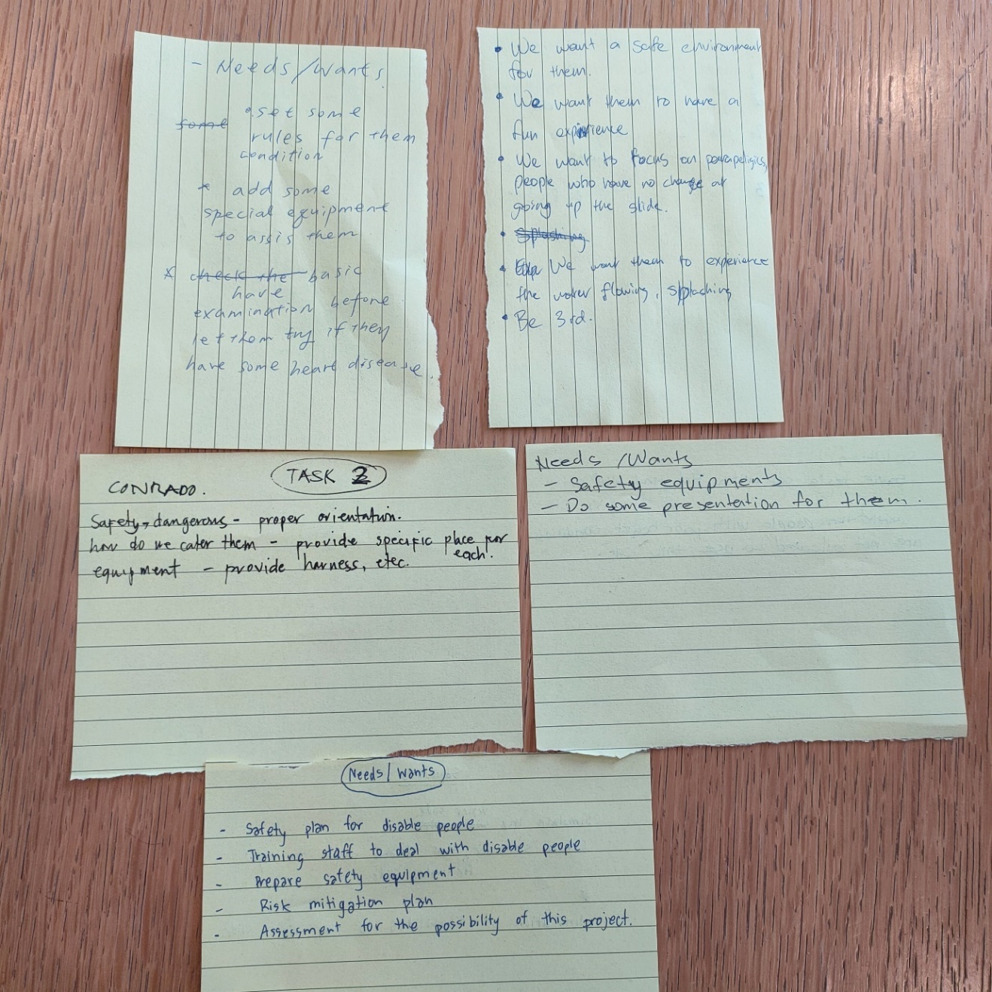Cost efficient.

**Task 3**

Overall, during our discussions as a team, we came up with many solutions. For example, just like when skydiving where you have someone with you, some came up with using Virtual Reality, others saying to use an autonomous vehicle or even a special seat that moves to simulate going down a water slide.

In the end using our combine ideas we all work together to make 3 solutions, 1 being a service and 2 being products.

1. A service where the person with a movement disability can physically go down the water slide with someone that is a trained staff or trained guardian with special equipment to keep them safe.
2. A product where an autonomous vehicle is used to simulate going down a slide with a virtual reality headset and sound effects to go along with it, so that they do not have to be physically at a water slide.
3. 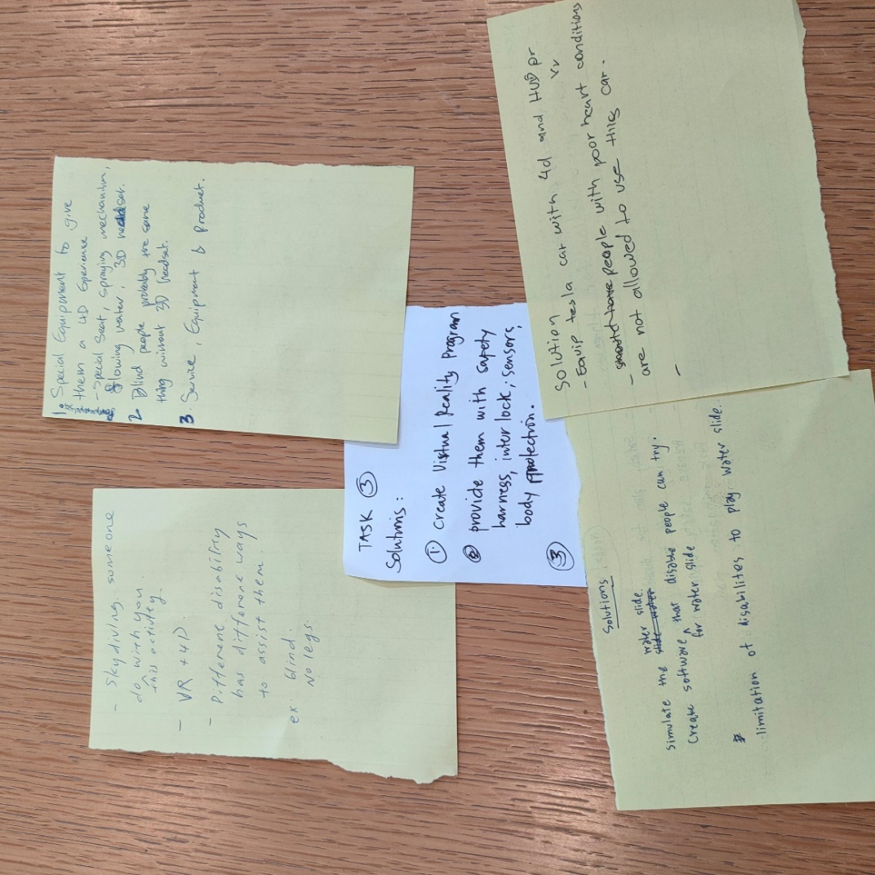A product where a special seat is made that goes along with a VR headset and sound effects to simulate the real thing with some 4D aspects.

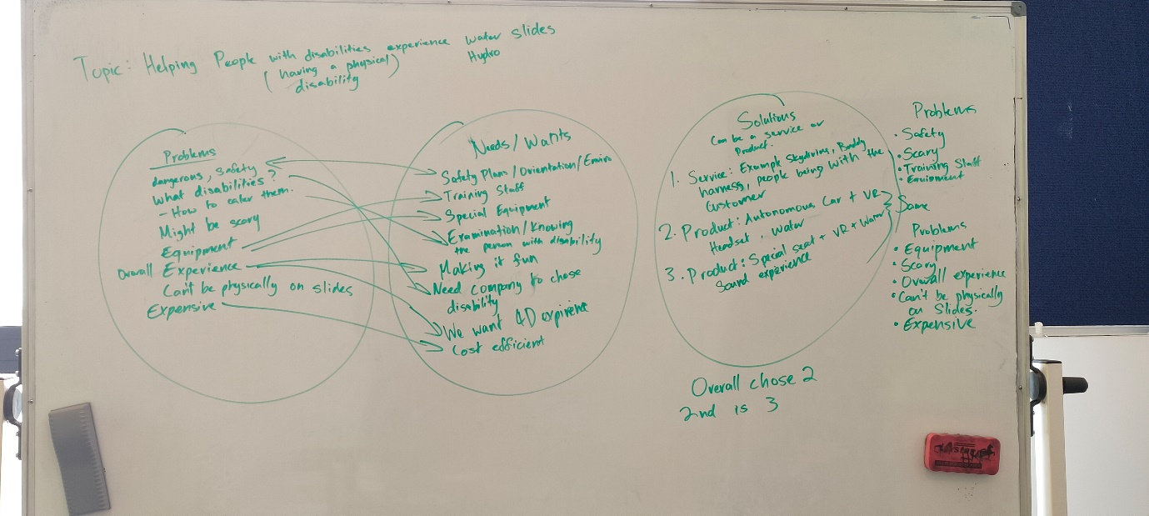In the end we chose 1 and 2 as the solutions to our chosen topic which are also according to the problems that we through up during task 2.

The picture above is our overall brainstorming for task 2 and 3.

**Task 4**

For the first solution this is the Lean Canvas that we did. **Strapped together safe.**

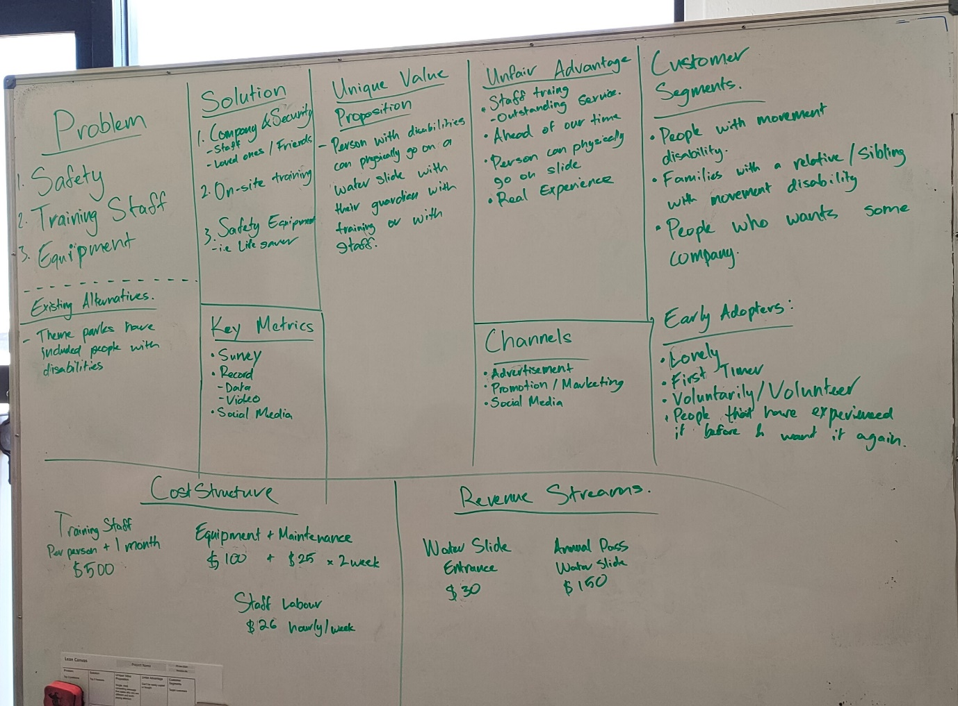

**The elevator pitch is:**

*“Are you someone who has a physical disability and has been wanting to know the feeling of going down a water slide feeling safe and with someone you know? In this case we have a water slide in which will keep you safe with equipment created specifically for you and you get to be accompanied by someone you know or trained staff. This is different from your usual water slide for it will keep you safe from dangers because of the equipment that will be used and whether you have no legs or arms you can guarantee the fun you will have.”*

In the end our target market are those people who are physically disabled who have never been on water slides and has been wanting to have that kind of experience. Our early adopters would be families who would like someone in the family who is disabled to also enjoy the same thing that has been enjoyed for a long time.

The second lean canvas for the other solution. **Autonomous car with a VR headset.**

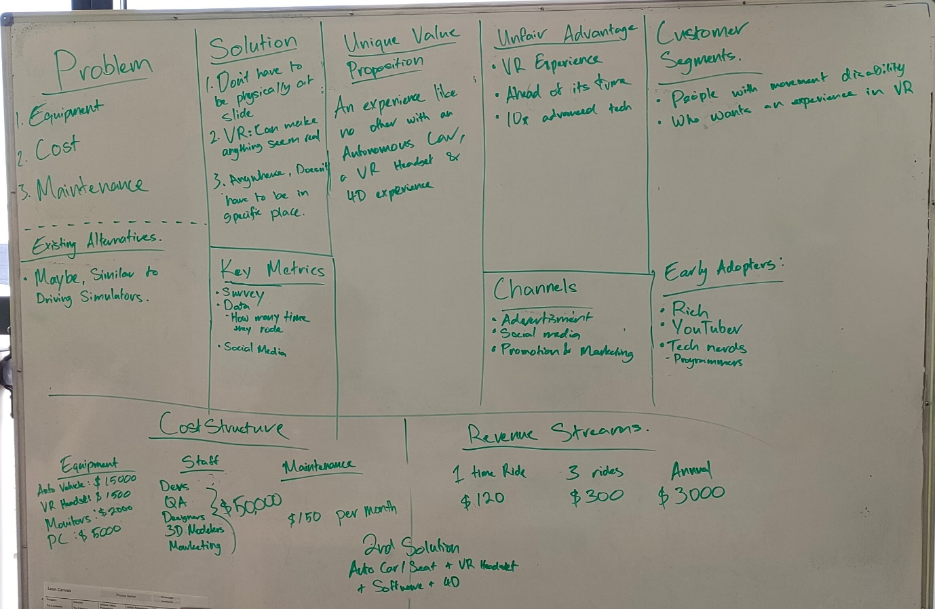

**The elevator pitch is:**

*“Are you someone who has a physical ability and scared of going down a water slide because you think it isn’t safe? Well, you do not have to be physically there but instead be in a safe autonomous vehicle with a VR headset to enjoy not only a water slide but maybe something else. Our solution is unique that it can be implemented anywhere and even give you different experiences not only water slides but maybe even rollercoasters and other carnival rides.”*

Overall, our target audience are not only those who are physically disabled but also those who want to experience something different like riding in an autonomous vehicle or a fantasy ride. Our early adopters would be people who are willing to try something different.

**Task 5**

In the end the idea that we all agreed on is the 2nd solution, is the **Autonomous car with a VR headset.** We then created 3 open-ended questions to help refine our idea. The three questions are:

1. What do you think about VR Headsets being used to give a real experience in a water slide to people who have movement disabilities?
2. Would you consider riding in an Autonomous Vehicle that is safe with a VR Headset to experience a water slide? Why?
3. Do you think people with movement disabilities would go on a ride like this? Why?

In the end we sent our questions to different people who were willing to answer our questions to help us refine our ideas. In total we were able to get 15 responses out of 30, those who responded are set in the excel sheet along with this file called ***Responses_listed.xlsx***.

That is where we all looked at the responses together and decided on what kind of feedback that each response to our question was trying to convey, whether it be positive, negative, people who have concerns or may be interested.

Out of the 15 responses we received 10 of them were either positive or curious to try out the solution but there were also positives with some concerns. While the rest of the responses were negative and questioning the overall safety and well-being of the people with movement disabilities.

## ***Conclusion***

Our conclusion is that we won’t be changing anything to our solution design to our problem topic. From the feedback we received since most of it was positive and peoples’ outlook is that it would be a great experience for people with movement disability. There is no harm in creating something that may give a new experience that has never been done before. With the concerns for the safety and well-being of the person with a movement disability this will be looked into the future once everything has been prototype, this is because with no prototype we won’t know if this solution will truly work.